Bank Loan Data SQL Queries

# Total Loan Applications

select count(id)as total_loan_applications from financial_loan;

C:\Users\Home\Pictures\Screenshot 2025-09-15 160708.png

• **MTD Loan Applications**

select count(id)as MTD_total_loan_applications from financial_loan  
where month(issue_date_new) = 12;



• **PMTD Loan Applications**

select count(id)as PMTD_total_loan_applications from financial_loan  
where month(issue_date_new)= 11;



# Total Funded Amount

• **Total Funded Amount**

select sum(loan_amount)as total_funded_amount from financial_loan



• **MTD Total Funded Amount**

select sum(loan_amount)as MTD_total_funded_amount from financial_loan  
where month(issue_date_new)=12;

C:\Users\Home\Pictures\Screenshot 2025-09-16 162200.png

• **PMTD Total Funded Amount**

select sum(loan_amount)as PMTD_total_funded_amount from financial_loan  
where month(issue_date_new)=11;

C:\Users\Home\Pictures\Screenshot 2025-09-16 162230.png

# Total Payment Received

select sum(total_payment)as Total_payment_received from financial_loan;

C:\Users\Home\Pictures\Screenshot 2025-09-16 162254.png

• **MTD Total Amount Received**

select sum(total_payment)as MTD_Total_payment_received from financial_loan  
where month(issue_date_new)=12;

C:\Users\Home\Pictures\Screenshot 2025-09-16 162310.png

• **PMTD Total Amount Received**

select sum(total_payment)as PMTD_Total_payment_received from financial_loan  
where month(issue_date_new)=11;

C:\Users\Home\Pictures\Screenshot 2025-09-16 162351.png

# Average Interest Rate

select avg(int_rate)*100 as Average_interest_rate from financial_loan;

C:\Users\Home\Pictures\Screenshot 2025-09-16 162418.png

• **MTD Average Interest**

select avg(int_rate)*100 as MTD_Average_interest_rate from financial_loan  
where month(issue_date_new)=12;

C:\Users\Home\Pictures\Screenshot 2025-09-16 162436.png

• **PMTD Average Interest**

select avg(int_rate)*100 as PMTD_Average_interest_rate from financial_loan  
where month(issue_date_new)=11;

C:\Users\Home\Pictures\Screenshot 2025-09-16 162502.png

# Average DTI

select avg(dti)*100 as Average_DTI from financial_loan;

C:\Users\Home\Pictures\Screenshot 2025-09-16 162546.png  
  
• **MTD Avg DTI**

select avg(dti)*100 as MTD_Average_DTI from financial_loan  
where month(issue_date_new)=12;

C:\Users\Home\Pictures\Screenshot 2025-09-16 162603.png  
  
• **PMTD Avg DTI**

select avg(dti)*100 as PMTD_Average_DTI from financial_loan  
where month(issue_date_new)=11;

C:\Users\Home\Pictures\Screenshot 2025-09-16 162618.png

# Good Loan Analysis

* **Good Loan Percentage**

select (count(case when loan_status="Fully Paid" or loan_status="Current"then id end)*100)/  
count(id) as Total_good_loan_percentage  
from financial_loan;

C:\Users\Home\Pictures\Screenshot 2025-09-16 162639.png

* **Good Loan Applications**

select count(id)as Good_loan_applictions from financial_loan  
where loan_status= "Fully Paid" or "Current";

C:\Users\Home\Pictures\Screenshot 2025-09-16 162658.png

* **Good Loan Funded Amount**

select sum(loan_amount)as Good_loan_funded_amount from financial_loan  
where loan_status="Fully Paid" or "Current";

C:\Users\Home\Pictures\Screenshot 2025-09-16 162721.png

* **Good Loan Amount Received**

select sum(total_payment)as Good_loan_received_amount from financial_loan  
where loan_status="Fully Paid" or "Current";

C:\Users\Home\Pictures\Screenshot 2025-09-16 162738.png

# Bad Loan Analysis

* **Bad Loan Percentage**

select (count(case when loan_status="Charged Off"then id end)*100)/  
count(id) as Total_bad_loan_percentage  
from financial_loan;

C:\Users\Home\Pictures\Screenshot 2025-09-16 162755.png

* **Bad Loan Applications**

select count(id)as bad_loan_applictions from financial_loan  
where loan_status="Charged Off";

C:\Users\Home\Pictures\Screenshot 2025-09-16 162810.png

* **Bad Loan Funded Amount**

select sum(loan_amount)as bad_loan_funded_amount from financial_loan  
where loan_status="Charged Off";

C:\Users\Home\Pictures\Screenshot 2025-09-16 162849.png

* **Bad Loan Amount Received**

select sum(total_payment)as bad_loan_received_amount from financial_loan  
where loan_status="Charged Off";

C:\Users\Home\Pictures\Screenshot 2025-09-16 162915.png

# Loan Status Summary

select loan_status,  
  
count(id) as total_loan_application,  
sum(total_payment)as total_loan_amount_received,  
sum(loan_amount)as total_funded_amount,  
avg(int_rate*100)as average_interest_rate,  
avg(dti*100)as DTI  
from financial_loan  
group by(loan_status);

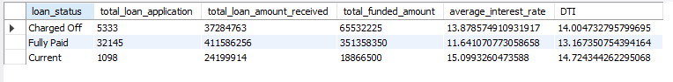  
  
BANK LOAN REPORT | OVERVIEW

# Monthly Loan Summary

SELECT   
 MONTH(issue_date_new) AS Month_number,  
 MONTHNAME(issue_date_new) AS Month_name,  
 COUNT(id) AS total_loan_applications,  
 SUM(total_payment) AS total_amount_received,  
 SUM(loan_amount) AS total_funded_amount  
FROM financial_loan  
GROUP BY Month_number, Month_name  
ORDER BY Month_number;

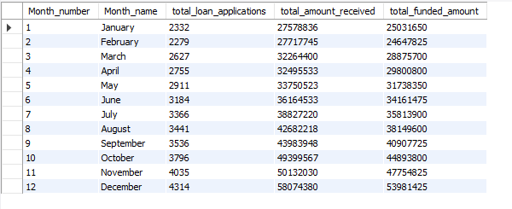

# State-wise Loan Summary

select address_state as State,  
count(id)as total_loan_application,  
sum(total_payment)as total_loan_amount_received,  
sum(loan_amount)as total_funded_amount  
from financial_loan  
group by state  
order by state;

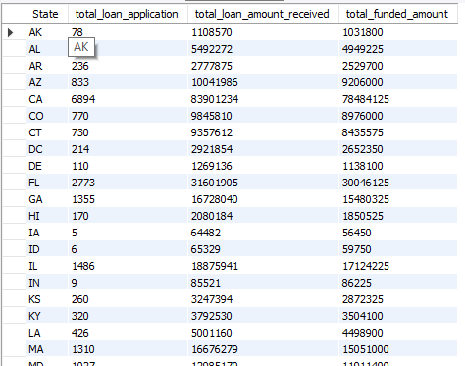  
  
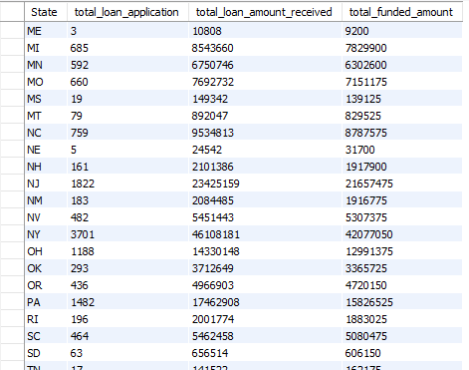

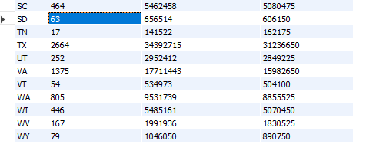

# Term-wise Loan Summary

select term as duration,  
count(id)as total_loan_application,  
sum(total_payment)as total_loan_amount_received,  
sum(loan_amount)as total_funded_amount  
from financial_loan  
group by duration;

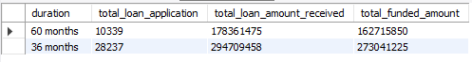

# Employment Length-wise Loan Summary

select emp_length as Employ_length,  
count(id)as total_loan_application,  
sum(total_payment)as total_loan_amount_received,  
sum(loan_amount)as total_funded_amount  
from financial_loan  
group by Employ_length;

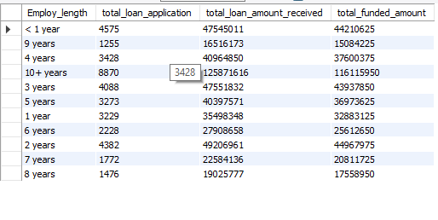

# Purpose-wise Loan Summary

select purpose as Purpose,  
count(id)as total_loan_application,  
sum(total_payment)as total_loan_amount_received,  
sum(loan_amount)as total_funded_amount  
from financial_loan  
group by Purpose;

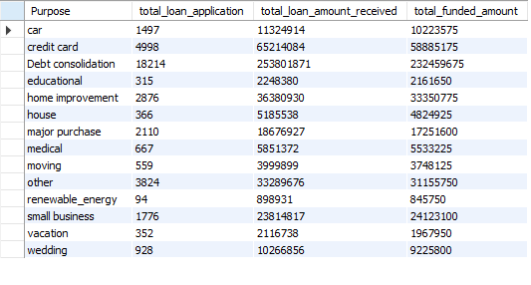

# Home Ownership-wise Loan Summary

select home_ownership as Home_Ownership,  
count(id)as total_loan_application,  
sum(total_payment)as total_loan_amount_received,  
sum(loan_amount)as total_funded_amount  
from financial_loan  
group by Home_Ownership;

